Powdermill 2010
Early tests done without background = Rossler config 1; others tests with background = Rossler config 3
Company/material name Threat Score Reflectance of Surface 1 IGU?
Certoplast tape on glass
10V
1” white vertical stripes spaced 4” edge to edge
No background, low sample size
Threat score 4

10H 1” white horizontal stripes spaced 4” edge to edge
No background
Threat score 21
Evonik
PLEXIGLAS SOUNDSTOP® GS CC 9 10 n0
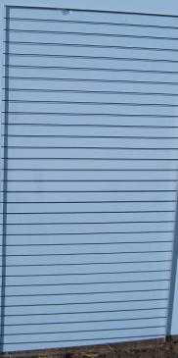
(black h plexi)
2mm embedded polyamide threads, spaced 28mm
(low sample size)

Viracon Glass Dot/Hole series
5065: 20% Coverage 22 11% yes
1/8” dots; no background

5065: 20% Coverage 41 11% yes
1/8” dots; with background

5006: 40% Coverage 24 11% yes
1/8” dots no background

Line Series
2256: 20% Coverage
1/8” lines
6 11% yes

Custom: 20% coverage
1/8” lines
10 11% yes
Company/material name Threat Score Reflectance of Surface 1 IGU?
CYRO Industries plexiglas
80% UV reflecting Plexiglas 52 8% in non-UV wavelengths no
No visible pattern
Window Alert
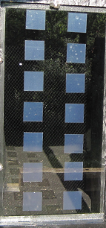
2x7
3.5” decals spaced 3.6” x 2”

Threat score no background 18

Threat score with background 24

3x7 3.5” decals spaced 2.5” x 2”
Threat score no background 3
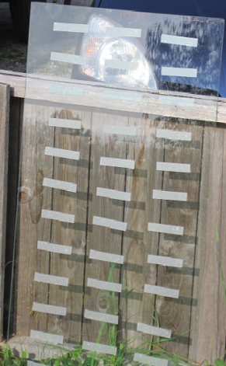
3x13
3.5”x0.9” decals spaced 2.5”x2”

Threat score no background 8

2x13 3.5”x0.9” decals spaced 3.6”x2”
Threat score no background 26
Company/material name Threat Score Reflectance of Surface 1 IGU?
Luremaking
UV Blast paint (reflects 14% UV) no background

2” stripes 2” apart 39 variable no
As above, on UV 26 variable no
absorbing film

2” stripes alternating
with 2” absorbing stripes 14 variable no

Solutia window film
No background
UV Pattern prototype 17 variable no

2” reflecting stripes x 2” absorbing stripes
Photo taken with UV camera (not our pattern)

Arnold Glass
Ornilux Mikado N33 Advance
Mikado (no background) 42 16 yes
Mikado (with background) 34 16 yes
These Mikado trials done using Arnold IGU control, visually different from plain glass, so these data not comparable (but huge sample sizes) and not used in LEED table

Company/material name Threat Score Reflectance of Surface 1 IGU?

SurfaceCare/Solyx?
2 mm grey stripes spaced 28 mm
30 variable no
Small sample size; Field data would predict better score

2011
Tunnel turntable starting to list and becoming harder to turn…..
Company/material name Score Reflectance of Surface 1 Insulated Glass?
Chart tape on glass, all with no background
.25” wide white vertical stripes spaced 4” (10V) Threat score 9
.25” wide white vertical stripes spaced 3” Threat score 17 (??)
.25” white horizontal stripes spaced 4”Threat score 11
.25” white stripes spaced 4” 72.5 degrees Threat score 5
.25” white stripes spaced 4” 45 degrees Threat score 8
1/8” black horizontal stripes spaced 1”Threat score 7
1/8” black vertical stripes spaced 2” Threat score 6
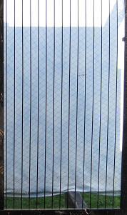

Arnold Glass
Grid
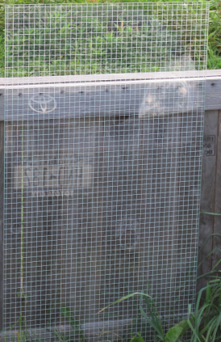
Threat score 45
(probably random)

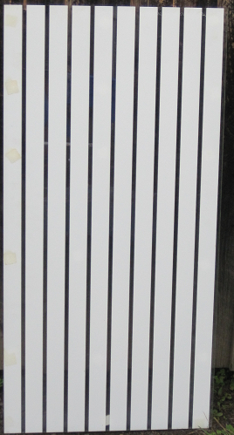
Not tested

Lots of dots

Threat score 68

(attracting birds)

2012
Guardian Glass
Photovoltaic Grey Crystal 23 6% yes
Not commercially available
Tested with background
Walker Glass tested with background
Reversed dots
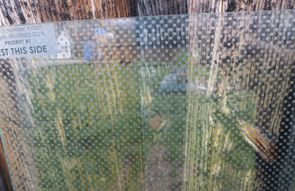
threat score 39

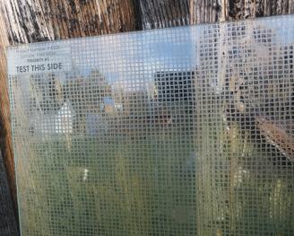
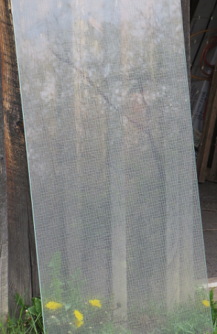
Fine mesh
Threat score 36.5

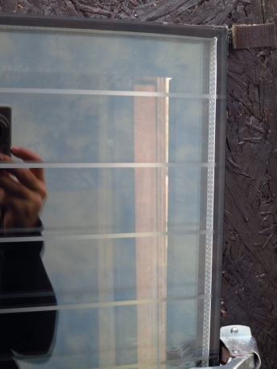
211/Continuous stripe
3 3” spacing
Threat score 28
(2013 score 34)

Velour
threat score 35

Arnold Glass
Unit 2 (commercially available – solar control glass)
Outside: 6mm Float Scandic (THIS SIDE IS OUTSIDE)
Cavity: 16mm spacer
Inside: 8mm laminated Float mikado (0.76 PVB)
threat score 23

Unit 7 (same configuration previously tested at Powdermill, commercially available, version in original LEED table) Mikado N33 Advance
Outside: 4mm Float mikado (non-tempered) (THIS SIDE IS OUTSIDE)
Cavity: 16mm spacer
Inside: 8mm laminated Float N33 (0.76 PVB)
Score 2012: 72.9 Trials: 85 WRONG! SHOULDN’T USE 2010 DATA,
Score 2010: 66.3 Trials:169 NEED TO CHANGE ORNILUX SCORE IN
Composite score: 68.5 TABLE
Threat score 27

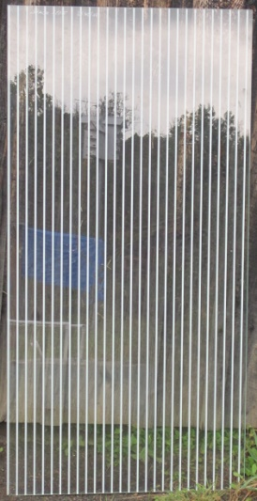
Unit 8: Laminated Screen Print on surface 1
White, vertical stripe; 3mm stripe / 15 mm space
Score 2012: insufficient trials (33)
Score 2011: 71.3 Trials: 94
Composite score: 73.2

Threat score 27 n/a no

Unit F12-8: 12 mm triple laminate guardrail glass
Tested without background
3 x’s 4 mm float; 2 x’s Mikado; 2 x’s 0.76 mm PVB
Threat score 52 Trials: 100

ALSO TESTED Ten ARNOLD IGU PROTOTYPES

2013
Walker Glass
Etched glass patterns
5??/Continuous stripe
3” spacing

Threat score 34

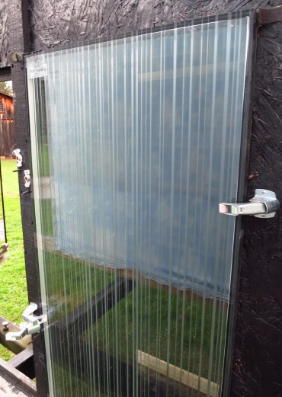
511/ Barcodes

Threat score 43
vertical lines variously 1/16" to 3/16" wide,
spaced variously 3/16" to 5/8" apart,
staggered across surfaces 1 and 2

512/ Ribbons
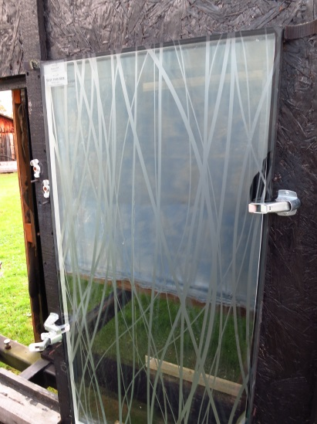Threat score 21

Convenience Group Feather Friendly
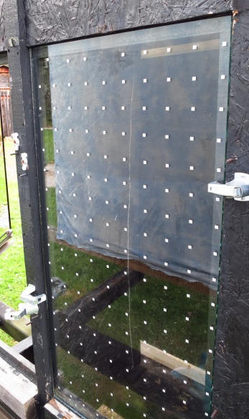
DIY tape
1/8” white squares, spaced 2” on center

Threat score 23

Arnold Glass
Sample 8-F 12 ORNILUX mikado mono 12mm
Tested with background
12mm laminated made of:
4mm Float mikado (face 2) / 0,76mm PVB / 4mm Float /
0,76mm PVB / 4mm Float mikado (face 5)
Threat Score 36 Trials=83

Tested in 2012 without background, with random result LEED score might need to be restricted to installations like balconies, where light on surface ½ is asymetric; would not apply for freestanding handrails or glass walls
14 Prototypes, some now commercially available
Including

ORNILUX mikado UNO // U-Value 1,0
Outside: 6mm Float mikado (to face 2)
Spacer: 10mm Argon
Inside: 8mm laminated 2x4 Float (0,76mm PVB) N10 (face 3)
Alternative low-E coating - with 70% light
transmission can be used as light solar control
threat score 26 trials 98

19-S13
ORNILUX mikado mono - laser I
4mm Float with lasered surface (face 1)
(face 1 = bird approach side)
on demand HJ Arnold
threat score 55 Trials: 80

20-S13
ORNILUX mikado mono - laser II
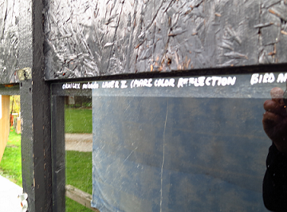
4mm Float with into glass lasered structure (face 1)
(Face 1 = bird approach side)
on demand HJ Arnold
threat score 58 Trials: 84

Ferro

Three more or less untestable prototypes

Guardian

Four visible pattern samples – possibly commercially available frit patterns?

PPG
Samples arrived at the very end of fall – 2 prototypes and various controls

