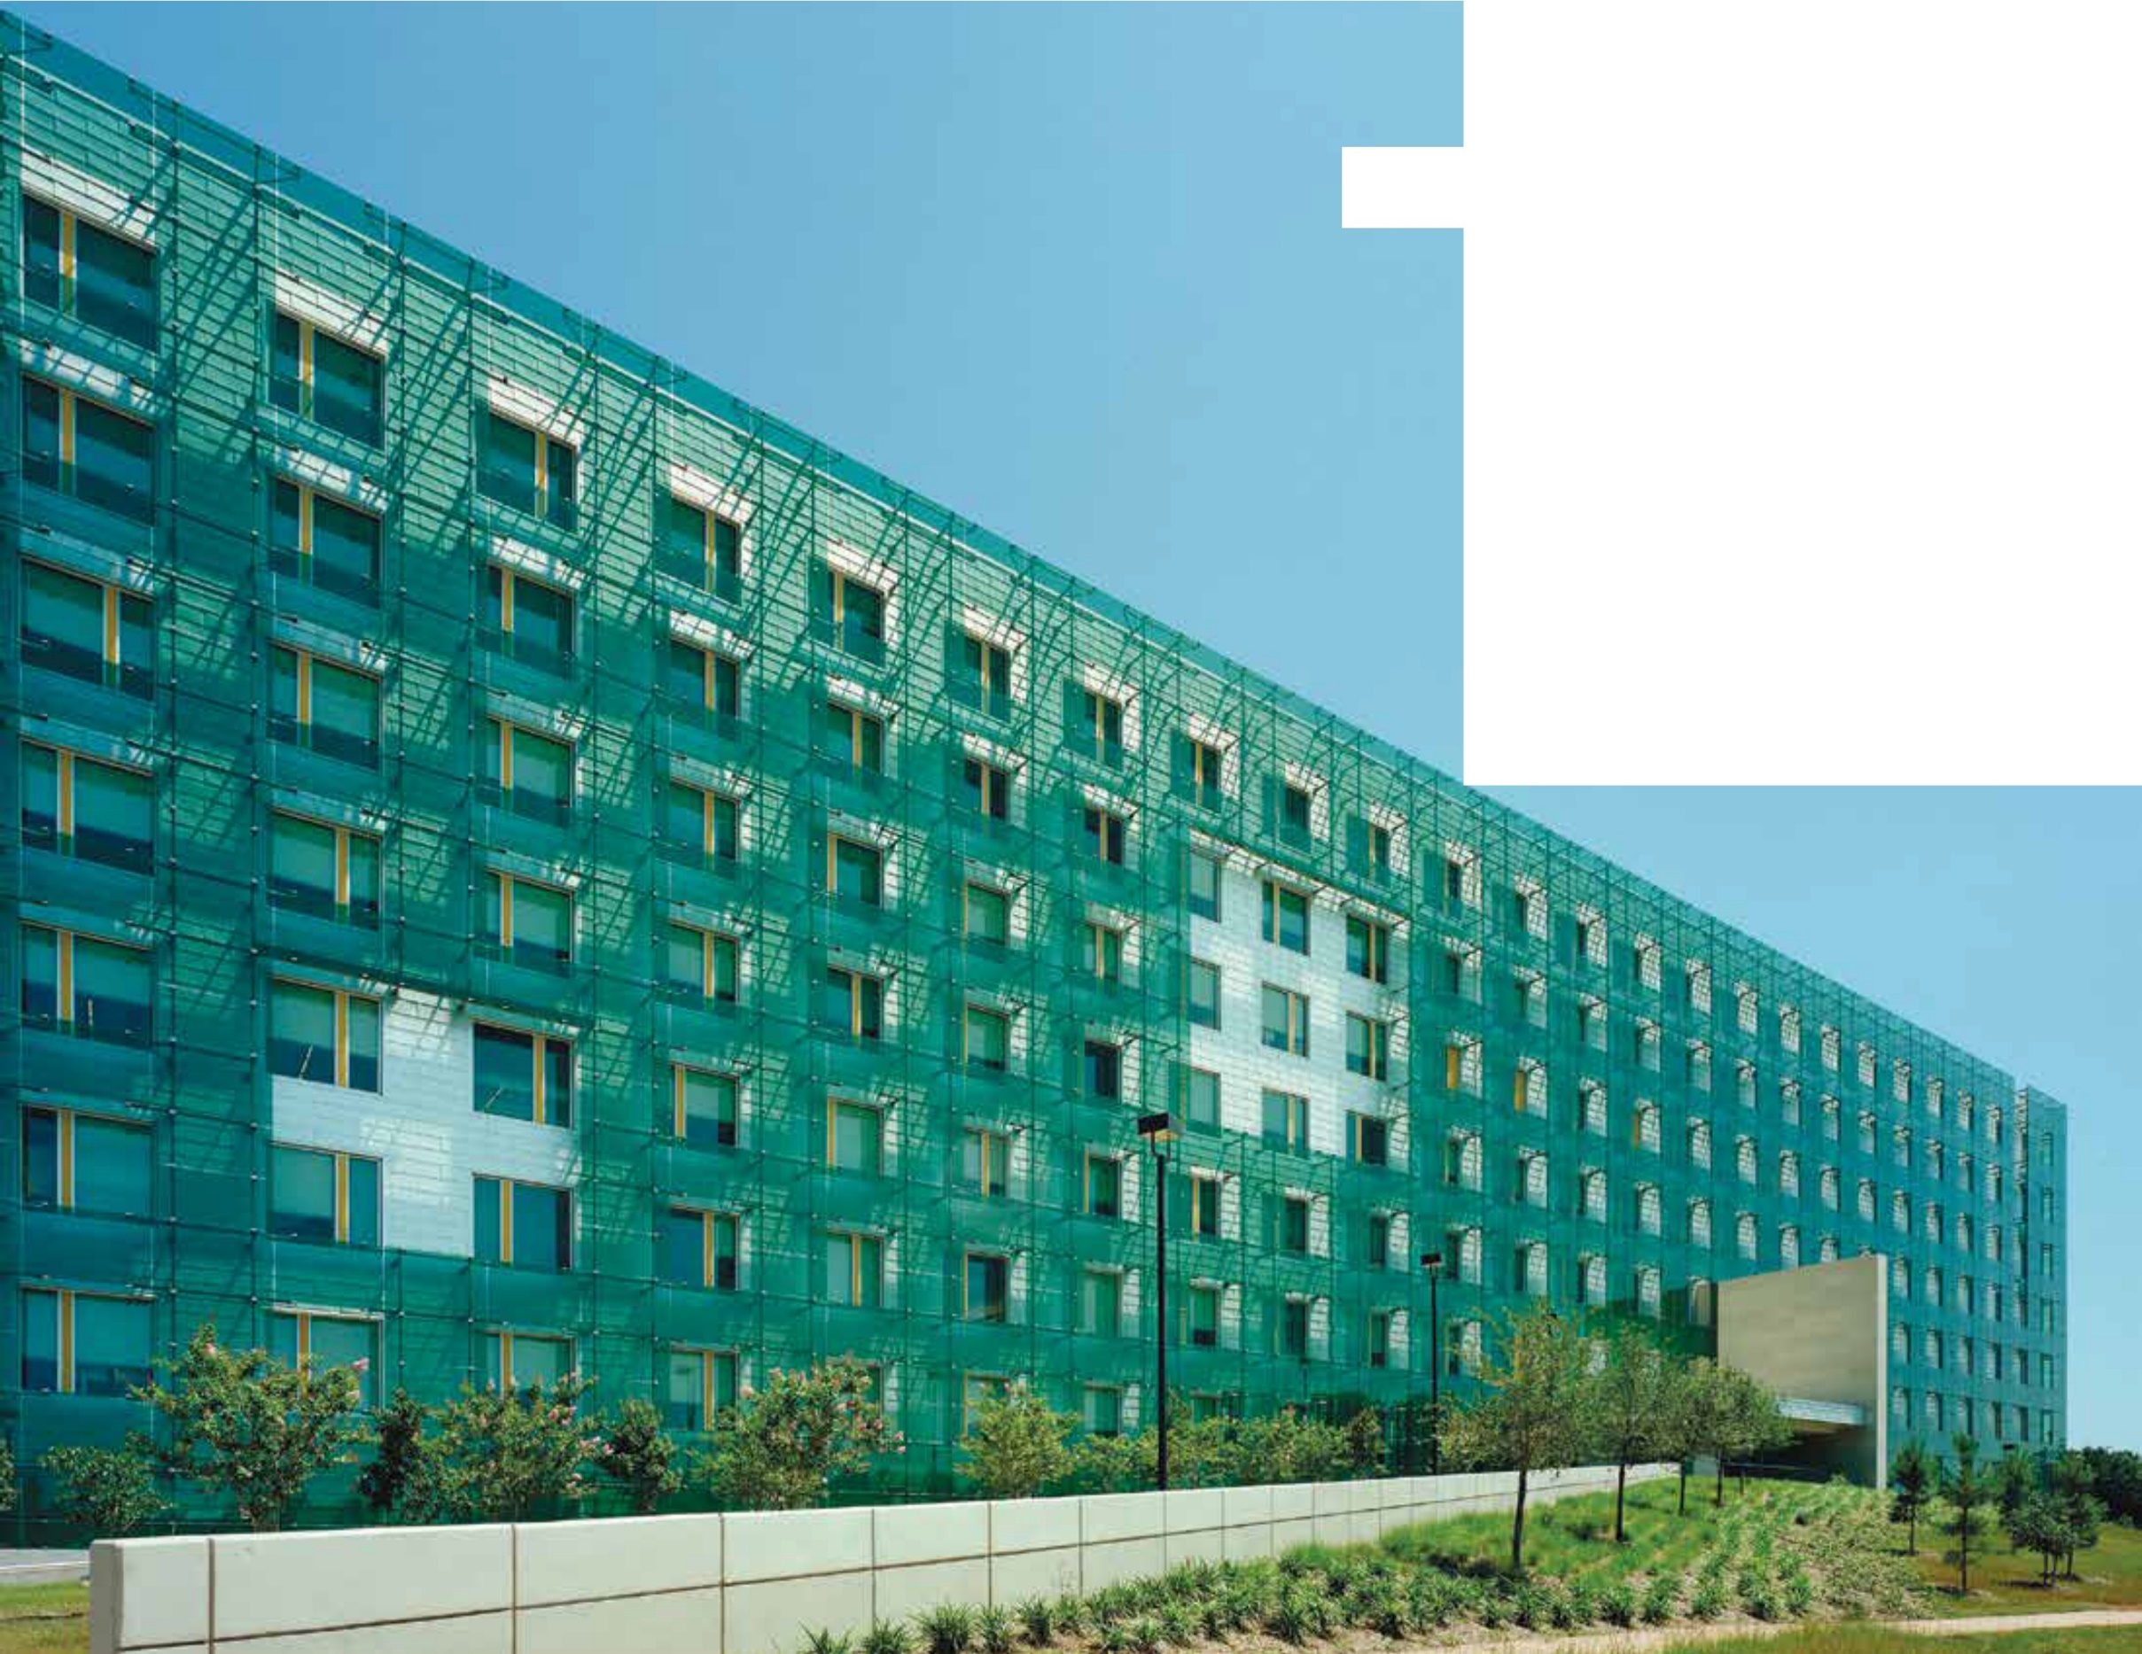
What’s Bird-friendlyGlass

It is possible to design buildings that can reasonably be expected to kill few or no birds. Numerous examples already exist, not necessarily designed with birds in mind but simply to be functional and attractive. These buildings may have many windows, but their screens, latticework, louvers, and other devices outside, or patterns integrated into the glass, warn birds before they collide. Finding glass treatments that can eliminate or greatly reduce bird mortality, while minimally obscuring the glass itself, has been the goal of several researchers, including Martin Rössler, Daniel Klem, and Christine Sheppard. Their work, discussed in more detail in the Science chapter, has focused primarily on the spacing, length, width, opacity, color, and orientation of elements marked on glass, and has shown that patterns covering as little as 5% of the total glass surface can deter most strikes under experimental conditions. They have shown that as a general rule, most songbirds will not attempt to fly through horizontal spaces less than
2 inches high or through vertical spaces 4 inches wide or less. We refer to this as the 2 x 4 rule, and it is clearly related to the size and shape of birds in flight. (See chart on page 47).
Designing a new structure to be bird-friendly does not require restricting the imagination or adding to the cost of construction. Architects around the globe have creat- ed fascinating and important structures that incorporate little or no dangerous glass. In some cases, inspiration has been borne out of functional needs, such as shad- ing in hot climates; in others, from aesthetics. Being bird-friendly usually has been incidental. Now, however, buildings are being designed with birds in mind, and materials designed for this purpose are multiplying. Un- til recently, retrofitting existing buildings has been more

(Opposite) The external glass screen on the GSA Regional Field Office in Houston, Texas, designed by Page Southerland Page, helps control heat but also reduces the likelihood of collisions. Photo by Timothy Hursley
difficult and costly than it is today. However, new mate- rials are appearing and costs can be controlled by target- ing problem areas rather than entire buildings.
Bird-friendly materials and design features often overlap in function with materials to control heat and light, security measures, and decorative design details. Bird- friendly building-design strategies also fall into three general categories, although all three could be combined in a single structure. These are:
- Using minimal glass (Bronx Call Center,
U.S. Mission to the United Nations)
- Placing glass behind some type of screening (de Young Museum, Cooper Union)
- Using glass with inherent properties that reduce collisions (Brooklyn Botanic Garden Visitors Center; Student Center at Ryerson University, Toronto; and Cathedral of Christ the Light)

Netting, Screens, Grilles, Shutters, Exterior Shades
There are many ways to combine the benefits of glass with bird-friendly design by incorporating elements that preclude collisions while providing light and views. Some architects have designed decorative façades that wrap entire structures. Decorative grilles are also part of many architectural traditions. Exterior, motorized solar screens and shades are effective at controlling heat and light, increase security, and can be adjusted to maximize view or bird and sun protection at different times. Net- ting, grilles, and shutters are common elements that can make glass safe for birds on buildings of any scale. They can be used in retrofit or be an integral part of an origi- nal design and can significantly reduce bird mortality.

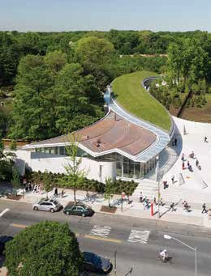
The Brooklyn Botanic Garden’s Visitors Center, designed by Weiss/Manfredi, was intended to be bird-friendly from its inception—a challenge, as it makes extensive use of glass. Photo @ Alber Vecerka, ESTO
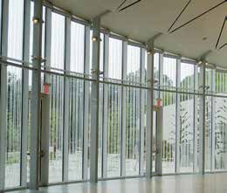
Glass walls and doors at the Brooklyn Botanic Garden’s Visitors Center include a custom fritting pattern that meets bird-friendly criteria. Monitoring for collisions after the building opened indicates that the design was successful. Photo by Christine Sheppard, ABC

Bird-Friendly Building Design 19

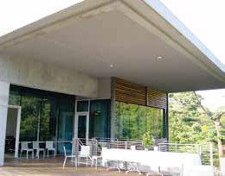
Overhangs block viewing of glass from some angles, but do not necessarily eliminate reflections. Photo by Christine Sheppard, ABC

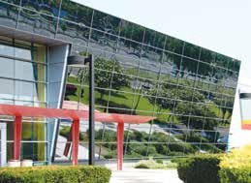
Reflections in this angled façade can be seen clearly over a long distance, and birds can approach the glass from any angle. Photo by Christine Sheppard, ABC

20 Bird-Friendly Building Design
Before the current age of unopenable windows, screens protected birds in addition to serving their primary purpose of keeping bugs out. Screens are still among the most cost-effective methods for protecting birds, and, if insects are not an issue, nearly invisible netting can often be installed. Screens and netting should be installed at some remove from the window so that the impact of a strike does not carry birds into the glass.
Several companies sell screens that can be attached with suction cups or eye hooks for small areas of glass. Others specialize in much larger installations. (Find sources at collisions.abcbirds.org).

Awnings and Overhangs
Overhangs have been frequently recommended to reduce collisions. However, there are many situations in which overhangs do not eliminate reflections and only block glass from the view of birds flying above. They are thus of limited effectiveness as a general strategy.
Overhangs work best when glass is shadowed from all sides. Functional elements such as balconies and
balustrades can block the view of glass, protecting birds while providing an amenity for residents.

Angled Glass
In a study (Klem et al., 2004) comparing bird collisions with vertical panes of glass to those tilted 20 or 40 de- grees, the angled glass resulted in less mortality. Klem speculated that this was because the glass reflected the ground, not vegetation. Using angled glass has become a common recommendation as a bird-friendly feature. However, while angled glass may be useful in special circumstances, the birds in the study were flying parallel to the ground from nearby feeders, hitting the glass at acute angles, with less force than a perpendicular strike. In most situations, however, birds may approach glass from any angle.

Patterns on Glass
Ceramic dots, other types of “frits,” and other materials can be screened, printed, or otherwise applied to glass surfaces. This is often done to reduce the transmission of light and heat and can also provide design detail. In some cases, frit patterns are hardly visible, but when designed according to the 2 x 4 rule (see p. 47), patterns on glass can also prevent bird strikes. Patterns on the outside surface of glass deter collisions most effectively because they are always visible, even with strong re- flections. This type of design, useful primarily for new construction, is currently more common in Europe and
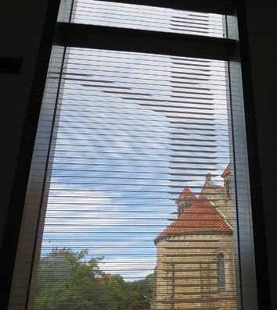
A custom frit pattern was designed by Ennead Architects for Vassar College’s Bridge for Laboratory Sciences building. Elements of the pattern occur on two separate surfaces, increasing visibility to birds in flight, who will see a constantly changing pattern that may appear to move. Photo by Christine Sheppard, ABC

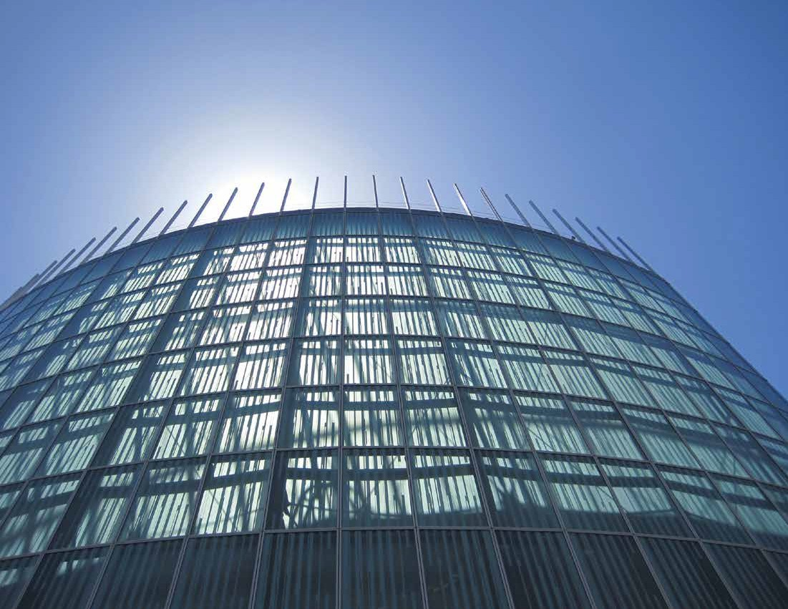
Frit patterns behind highly reflective glass may not always be visible. However, in buildings like Skidmore Owings Merril’s Cathedral of Christ the Light, the frit pattern is always visible and the pattern should appear as a virtual barrier, deterring birds from flying into it. Photo by Christine Sheppard, ABC
Bird-Friendly Building Design 21

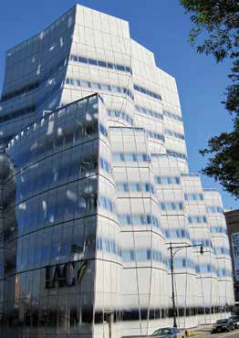
While some internal fritted glass patterns can be overcome by reflections, Frank Gehry’s IAC headquarters in Manhattan is so dense that the glass appears opaque. Photo by Christine Sheppard, ABC
Ornilux Mikado’s pattern reflects UV wavelengths. The spiderweb effect is visible only from very limited viewing angles. Photo courtesy of Arnold Glass
Asia, but is being offered by an increasing number of manufacturers in the United States. New technologies allowing printing of ceramic inks on the outside surface of glass may greatly increase options for bird-friendly design in the U.S.
More commonly, frit is applied to an internal surface of insulated glass units. This type of design may not be visible if the amount of light reflected by the frit is insufficient to overcome reflections on the outside
surface of the glass or if frit is applied as dots below the visual threshold of birds. Some internal frits may only help break up reflections when viewed from some angles and in certain light conditions. However, with the right combination of surface reflectivity and frit application,
a pattern on an inside surface can still be effective. The headquarters of the internet company IAC in New York City, designed by Frank Gehry, is composed entirely of fritted glass, most of high density and always visible. No collision mortalities have been reported at this building after two years of monitoring by New York City Audubon. FXFOWLE’s Jacob Javits Center, also in Manhattan, reduced collisions by as much as 90% with a renovation that eliminated some dangerous glass and replaced other glass with a visible frit pattern. Another example of a visible internal frit pattern is seen in Skidmore Owings Merril’s Cathedral of Christ the Light in Oakland, California.

UV Patterned Glass
Songbirds, gulls, parrots, and other birds can see into the ultraviolet (UV) spectrum of light, a range largely invisible to humans (see page 41). Other bird types, including raptors, kingfishers, hummingbirds, and pigeons, are less sensitive to UV. Ultraviolet reflective and/or absorbing patterns “invisible to humans but
visible to birds” are frequently suggested as the optimal solution for many bird collision problems, but few such products are available commercially as of 2015.
Progress in development of bird-friendly UV glass has been slow, but with legislation in multiple locations mandating bird-friendly design, glass manufacturers and distributors, as well as window-film manufacturers, are taking an active role in developing new solutions for this application. Research indicates that UV patterns need strong contrast to be effective, especially in the early morning and late afternoon, when UV in sunlight is
at low levels. However, UV patterns may be ineffective for many species that have been reported as victims
of collisions with glass, including hummingbirds, flycatchers, American Woodcock, and woodpeckers.

Opaque and Translucent Glass
Opaque, etched, stained, or frosted glass and glass block are excellent options to reduce or eliminate collisions, and many attractive architectural applications exist.
They can be used in retrofits but are more commonly used in new construction. Frosted glass is created by acid etching or sandblasting transparent glass. Frosted areas are translucent, but various finishes are available with differing levels of light transmission. An entire
surface can be frosted, or frosted patterns can be applied.
Patterns should conform to the 2 x 4 rule described on page 47. For retrofits, glass also can be frosted by sandblasting on site. Stained glass is typically seen in
relatively small areas but can be extremely attractive and is not conducive to collisions. Glass block is versatile, can be used as a design detail or primary construction material, and is also unlikely to cause collisions. Another promising material is photovoltaic glass, which has
been used in stained-glass windows and highway noise barriers. This solution is especially interesting, because

22 Bird-Friendly Building Design

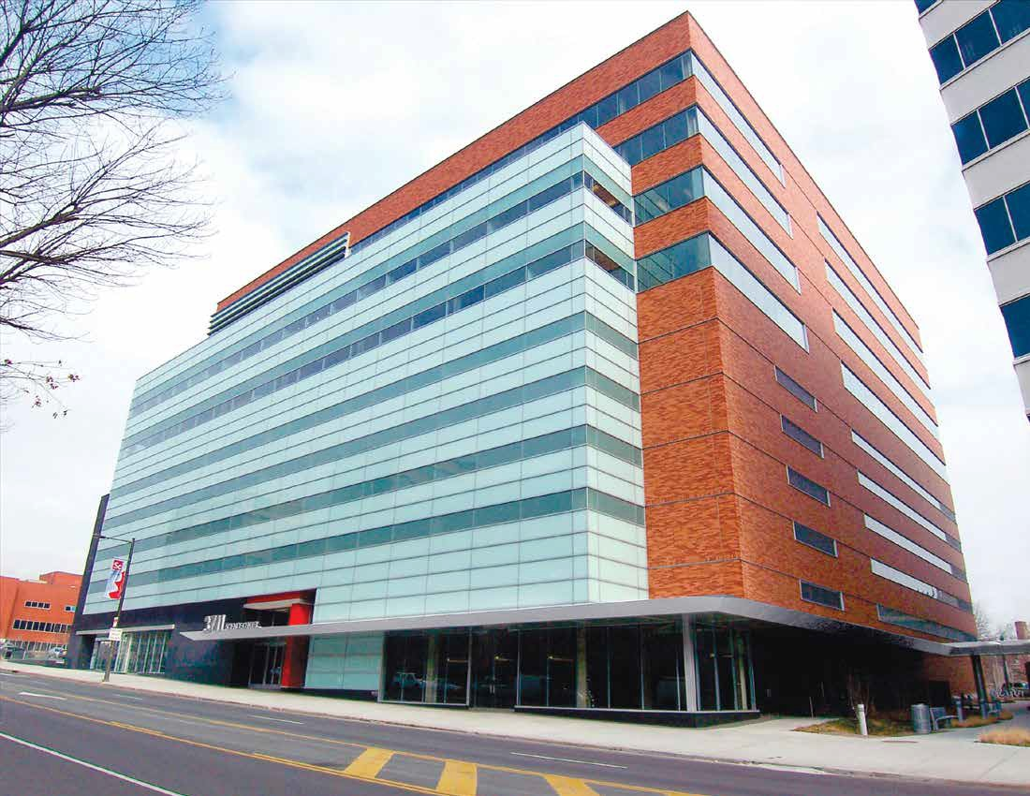

The Wexford Science and Technology Building in Philadelphia, designed by Zimmer, Gunsul, Frasca, uses translucent glass
to provide light without glare, making it safe for birds. Photo courtesy of Walker Glass
Bird-Friendly Building Design 23

transparent highway noise barriers can cause collisions, and such barriers are beginning to be installed in the United States.

Window Films
Most patterned window films were initially intended for use inside structures as design elements or for privacy. Now, outside surface applications intended to reduce

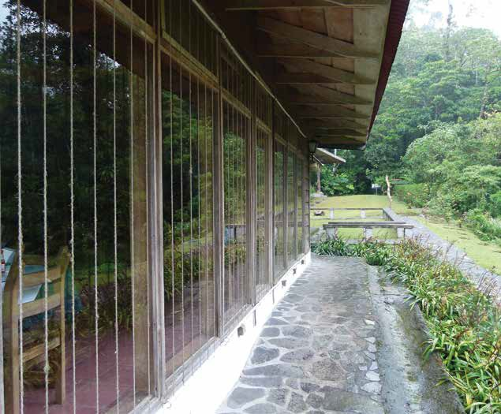
bird collisions are coming onto the market, and some have proved highly effective and popular. The oldest such product creates an opaque white surface on the out- side of glass that still permits viewing from the inside.
Patterns can be printed on this material, although im- ages of trees and other habitat are not recommended.
A film with a pattern of narrow, horizontal stripes has eliminated collisions at the Philadelphia Zoo Bear Coun- try exhibit for over five years (see photo opposite) and has been similarly successful in other installations when applied to outside surfaces of glass. In these cases, the response has been positive. Another option is to apply vinyl patterns like window film but with the transparent backing removed.

Solutions Applied to Interior Glass
Light colored shades have been recommended as a way to deter collisions. However, when visible, they do not effectively reduce reflections, and reflections may make them completely invisible. Closed blinds have the same problems, but if visible and partly open, they can pro- duce the appearance of a 2 x 4 pattern. If an exterior so- lution is not possible and tape or sticky notes are applied to the inside of windows, be sure to check the windows several times a day to ensure that these materials are visible.

Decals and Tape
Decals are probably the most familiar solution to bird collisions, but their effectiveness is widely misunderstood. Birds do not recognize decals as

A Zen Wind Curtain is an inexpensive but extremely effective way to deter collisions. Lengths of parachute cord or similar materials are strung vertically, every four inches, in front of problem glass, creating both a visual and a physical barrier. Photo by Glenn Phillips

24 Bird-Friendly Building Design

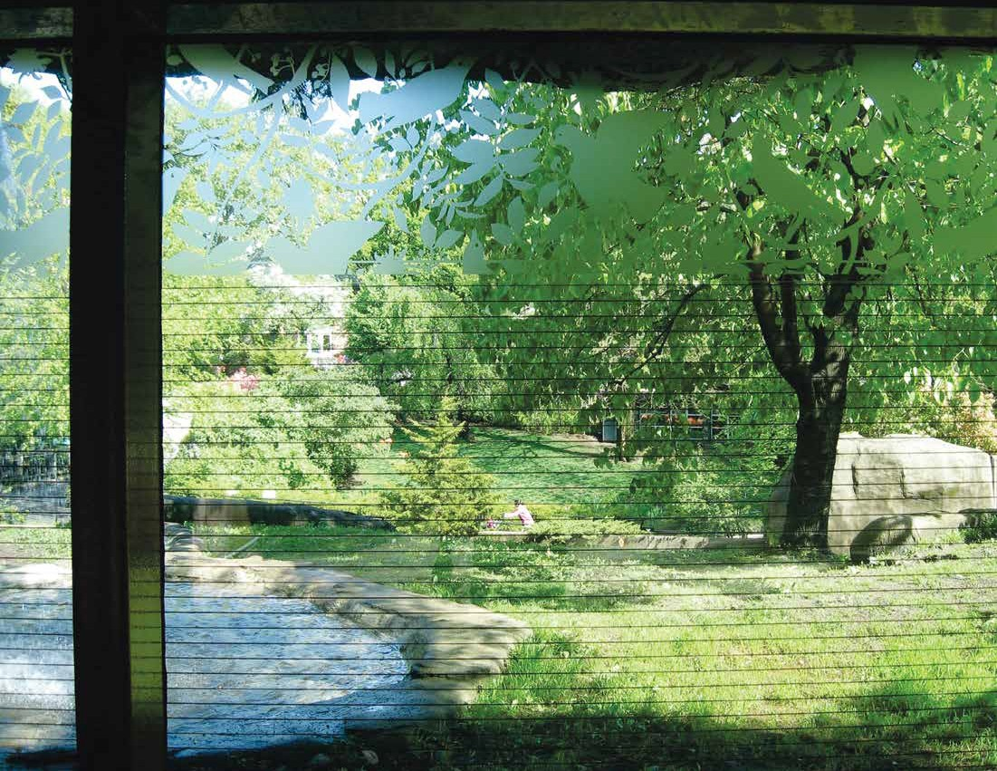

This window at the Philadelphia Zoo Bear Country exhibit was the site of frequent bird collisions until window film was applied. Collisions have been eliminated for over five years, with no complaints from visitors about visibility of bears! Photo courtesy of the Philadelphia Zoo
Bird-Friendly Building Design 25

26 Bird-Friendly Building Design
silhouettes of falcons, spiderwebs, or other natural objects, but simply as obstacles that they may try to fly around. Decals can be very effective if applied following the 2 x 4 rule on the outside of glass, but in general, they must be replaced frequently, at least annually. Tape is generally more cost effective and quicker to apply,
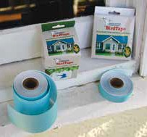
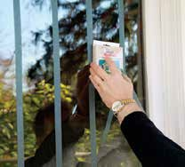
but most household tapes don’t stand up well to the elements. Tape intended to last for several years on the outside of windows has become commercially available and is effective when applied following the 2 x 4 guide.
ABC BirdTape

ABC, with support from the Rusinow Family Foundation, has produced ABC BirdTape to make home windows safer for birds. This easy-to-apply tape lets birds see glass while letting you see out, is easily applied, and lasts up to four years.
For more information, visit abcbirdtape.org

Photos by Dariusz Zdziebkowski, ABC

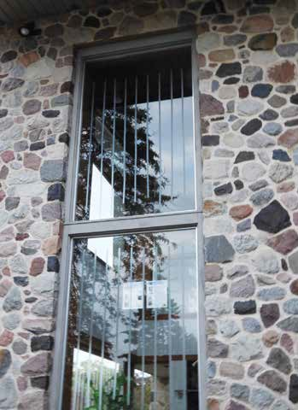

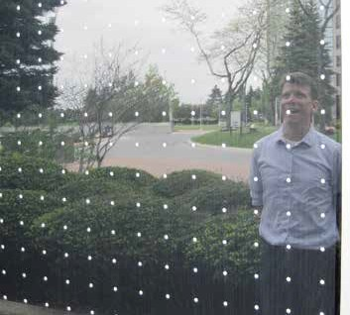
The Consilium Towers, a mirror-glass complex in Toronto, once killed thousands of birds each year. After being taken to court, its owners retrofitted the lower 60 feet of glass with a Feather Friendly dot pattern that has greatly reduced bird mortality.
Reflected in this glass is Michael Mesure, the founder of Toronto's Fatal Light Awareness Program. Photos by Christine Sheppard, ABC

Temporary Solutions
In some circumstances, especially for homes and small buildings, quick, low-cost, temporary solutions, such as making patterns on glass with paint, stickers, or even post-its, can be very effective in the short term. Even a modest effort can reduce collisions. Such measures can be applied when needed and are most effective follow- ing the 2 x 4 rule. (For more information, see ABC’s flyer “You Can Save Birds from Flying into Windows” and other sources at collisions.abcbirds.org).

ABC BirdTape was effective at the Forest Beach Migratory Reserve in Wisconsin (left), and also performed well in tunnel tests conducted in Austria. Photo by Christine Sheppard, ABC

REMEDIATION CASE STUDY:
Javits Center

In 2009, the New York City Audubon Society identified the Jacob K. Javits Convention Center as having one of the highest bird-collision mortality rates in New York City.

A major renovation and expansion, designed by the bird-friendly architectural firm of FXFOWLE, was com- pleted in 2014. Some especially deadly glass at street level was replaced with opaque panels. Large panes of clear fritted glass with varying surface characteristics were brought to the site and compared to find the right combination for birds and people.
A 6.75-acre green roof, with adjacent translucent glass, crowns the building and is already providing resources for birds.
Best of all, collisions at the now much larger site have been reduced by 90%.

From a distance, the Javits Center looks like a potential threat to birds.

At close range, a visible pattern of frit dots breaks up reflections, making the glass safe for birds. Photos by Glenn Phillips

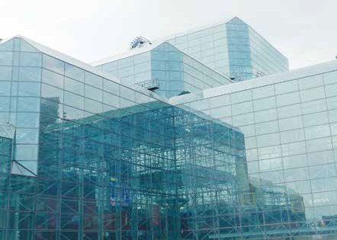
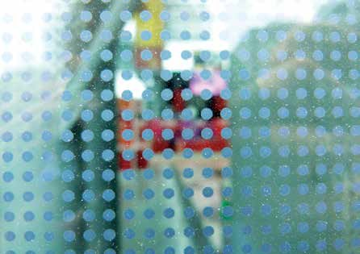

Bird-Friendly Building Design 27

Photo by Larry Vincent

